本系列文章是基于QtContact一些研究，用来实现一个MeeGo中的通讯录。该通讯录可以和社交网络，及时通讯工具实现无缝连接。  
**1、首先看一下通讯录的架构图**  
[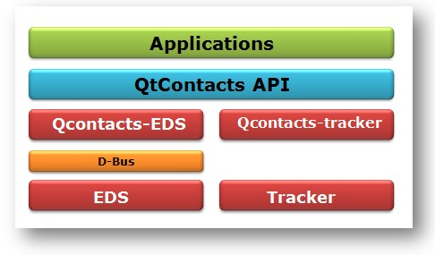](http://software.intel.com/sites/default/files/m/a/e/2/c1.jpg)  
  
**2、通讯录中的基本数据类型**  
  
Data Type Description  
QContactAddress Contains an address of a contact  
QContactAnniversary Contains an anniversary of a contact  
QContactAvatar Contains avatar URLs of a contact  
QContactBirthday Contains a birthday of a contact  
QContactDisplayLabel The (possibly synthesized) display label of a contact  
QContactEmailAddress Contains an email address of a contact  
QContactFamily Contains names of family members of a contact  
QContactFavorite Indicates if a contact is a favorite contact as well as the position it should appear in an ordered list of favorites  
QContactGender Contains the gender of a contact  
QContactGeoLocation Contains a global location coordinate associated with a contact  
QContactGlobalPresence Aggregated presence information for a contact, synthesized or supplied by the backend  
QContactGuid Contains a globally unique Id of a contact, for use in synchronization with other data stores  
QContactHobby Contains a hobby of the contact  
QContactName Contains a name of a contact  
QContactNickname Contains a nickname of a contact  
QContactNote Contains a note associated with a contact  
QContactOnlineAccount Online account, which the contact uses to communicate with friends and family  
QContactOrganization Details about an organization that the contact is either a part of, or stands for  
QContactPhoneNumber Phone number of a contact  
QContactPresence Presence information for an online account of a contact  
QContactRingtone Ringtone associated with a contact  
QContactSyncTarget Sync target for a contact  
QContactTag Contains a tag associated with a contact  
QContactThumbnail Contains a thumbnail used in display lists to represent the contact  
QContactTimestamp Contains the creation and last-modified timestamp associated with the contact  
QContactType Describes the type of the contact  
QContactUrl Contains a url associated with a contact  
  
**3.存储方案**  
目前Qt Contacts提供两种存储方案。  
1.EDS；将在MeeGo 1.2及以后版本中使用。  
2.Tracker；在MeeGo1.2及MeeGo Harmattan系统中使用，但是今后将不再使用，统一到EDS平台  
  
**4.存储实现步骤**  
  
[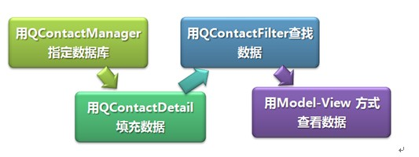](http://software.intel.com/sites/default/files/m/3/f/9/c2.jpg)